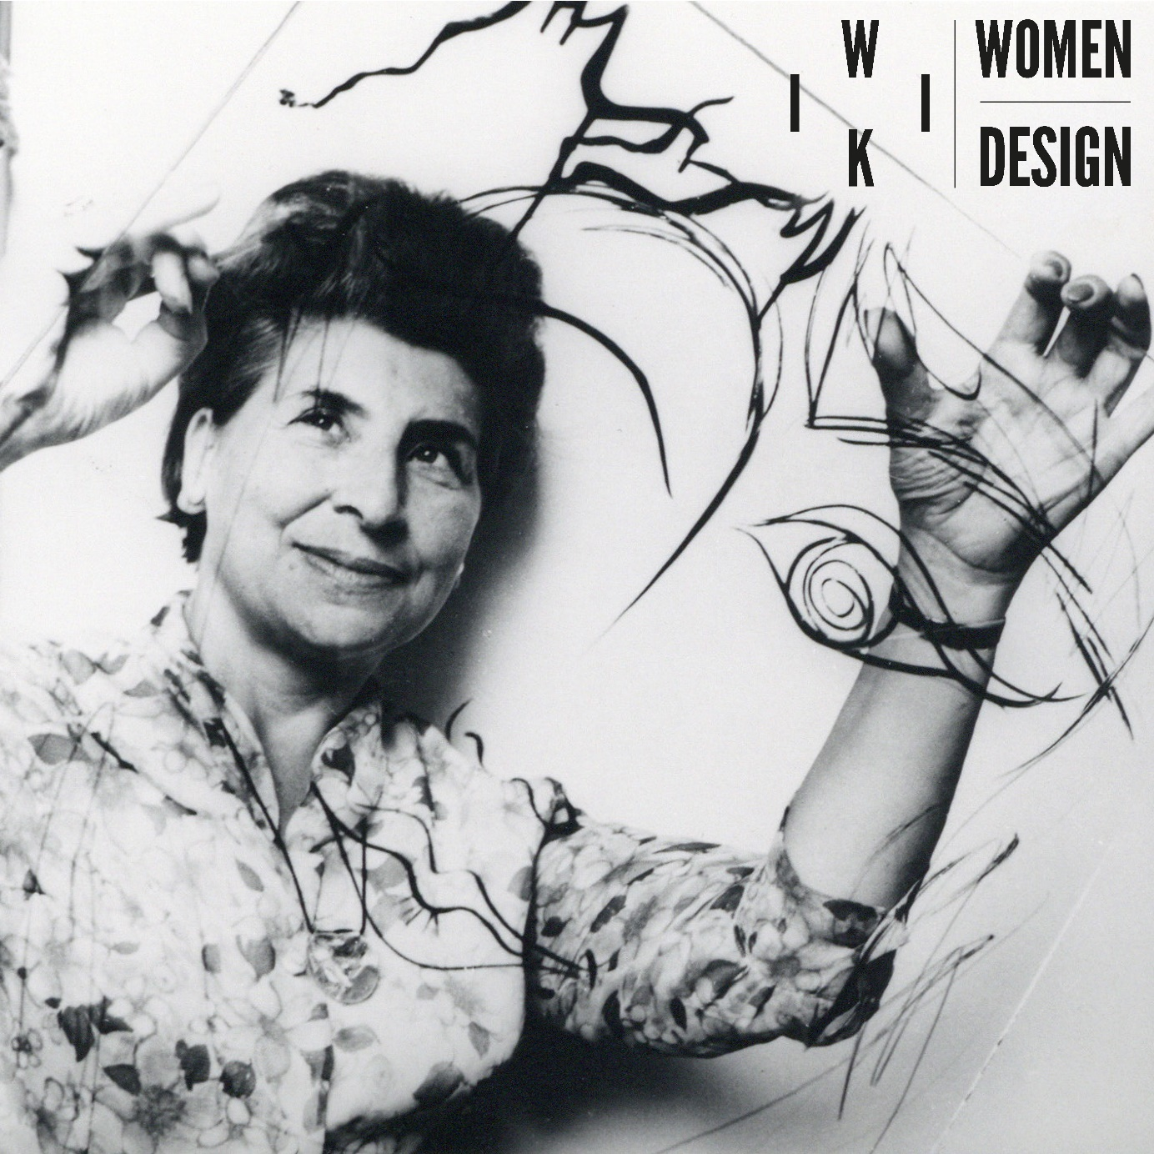

Wiki Women Design
PRESS KIT

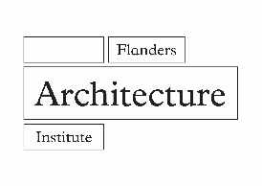
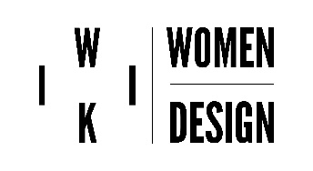
Contents
Press release 3
Ambassadors 8
Quotes 17
Press images 20
Writing sessions 36
Practical information 39

Press release
With Wiki Women Design, the Flanders Architecture Institute strives to bring women who have left their mark on Belgium's design heritage out of the shadows of history. Many women contributed to the designed environment, from (interior) architecture and graphic design to fashion and product design. Nevertheless, many remained under the radar of heritage institutions, researchers and collectors. With Wikipedia as a platform and edit-a-thons or writing sessions as a means, Wiki Women Design aims to make up for this backlog.

“Invisibility is a sign that there is still much more work to do.” – Jane Hall (architect, author of Breaking Ground. Architecture by Women (2019))

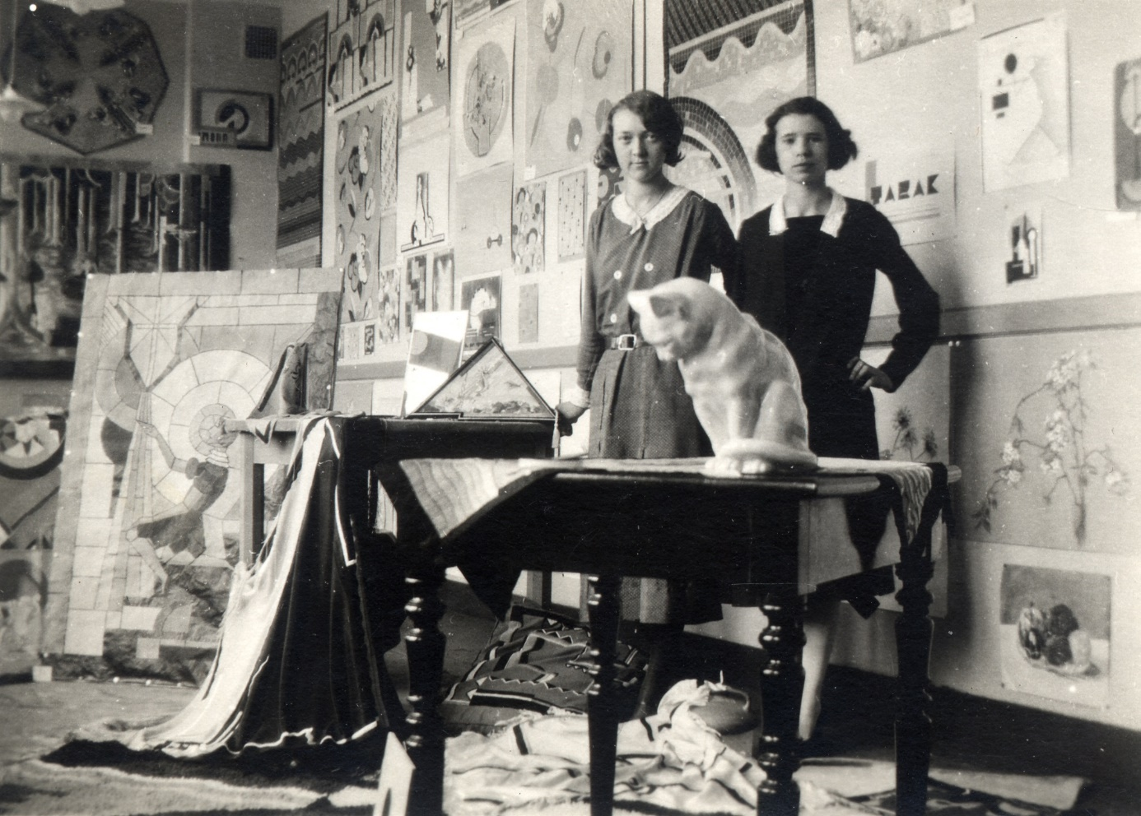 Martha Van Coppenolle in an atelier with a friend, 1931. Collection City of Antwerp, Letterenhuis.

Renovatio memoriae: breaking a vicious circle
To date, there are hardly any studies on female designers in Belgium, although they have (had) an important influence on the designed environment. Despina Stratigakos compares the forgetting of female architects with the ancient Roman concept of damnatio memoriae, the erasure of persons and their legacy from memory. The absence of female designers in the collective memory is largely due to their relative absence from history books, which in turn has to do with their under-representation in design archives and collections. Due to the absence of such sources, little is known today about women's activities, even in the fields in which they were very active according to literature. Wiki Women Design wants to break this vicious circle, make women's contributions to the Belgian designed environment known and contribute to a more inclusive history. By unlocking the contributions of female designers on Wikipedia, the project also wants to contribute to the creation of female role models for future designers and to gender equality in the design disciplines.
“Patriarchal expectations and masculinist values are very deeply ingrained in this [architectural] culture, although few of its practitioners are aware of this strong but implicit bias. It will therefore require a conscious and shared effort of all those involved to change all this and to leave sexism behind.” – Hilde Heynen (professor architectural theory, KU Leuven)
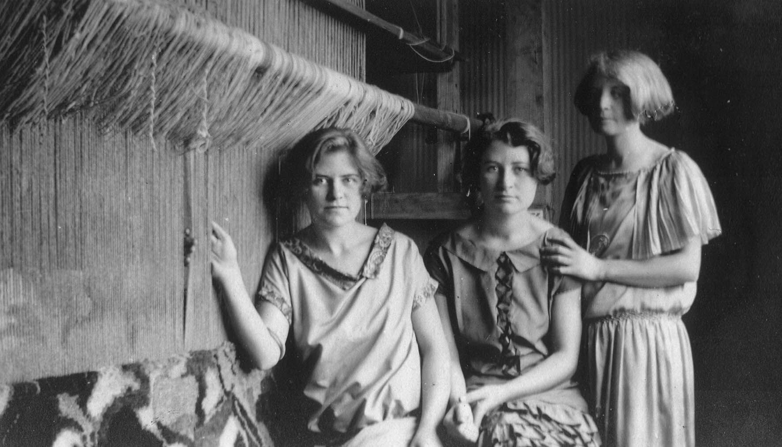
Elisabeth De Saedeleer and two sisters, 1923 © Archives of Contemporary Art, Royal Museums of Fine Arts of Belgium, Businarias

Making female designers Googleable
Wikipedia is the fifth most visited website in the world, making the articles of this encyclopedia among the first results of Google searches. As Google is an important window on the world for many, Wikipedia has a huge impact on knowledge acquisition and historiography. However, women are also strongly underrepresented on Wikipedia, both as authors and as subjects. Through close collaboration with numerous partners, Wiki Women Design aims to complete the online encyclopedia and give more visibility to the women who have left their mark on the design heritage in Belgium. Archive and heritage institutions, researchers and teachers, contemporary designers, the Wikipedia community and many enthusiastic students and volunteers are all part of the effort.
The collaborative and participatory effort to build knowledge fits in perfectly with the core philosophy of Wikipedia and forms the foundation of this project.
“[...] while histories of women are now increasingly available, they have yet to become readily visible.”
– Despina Stratigakos (professor architectural history, University at Buffalo)
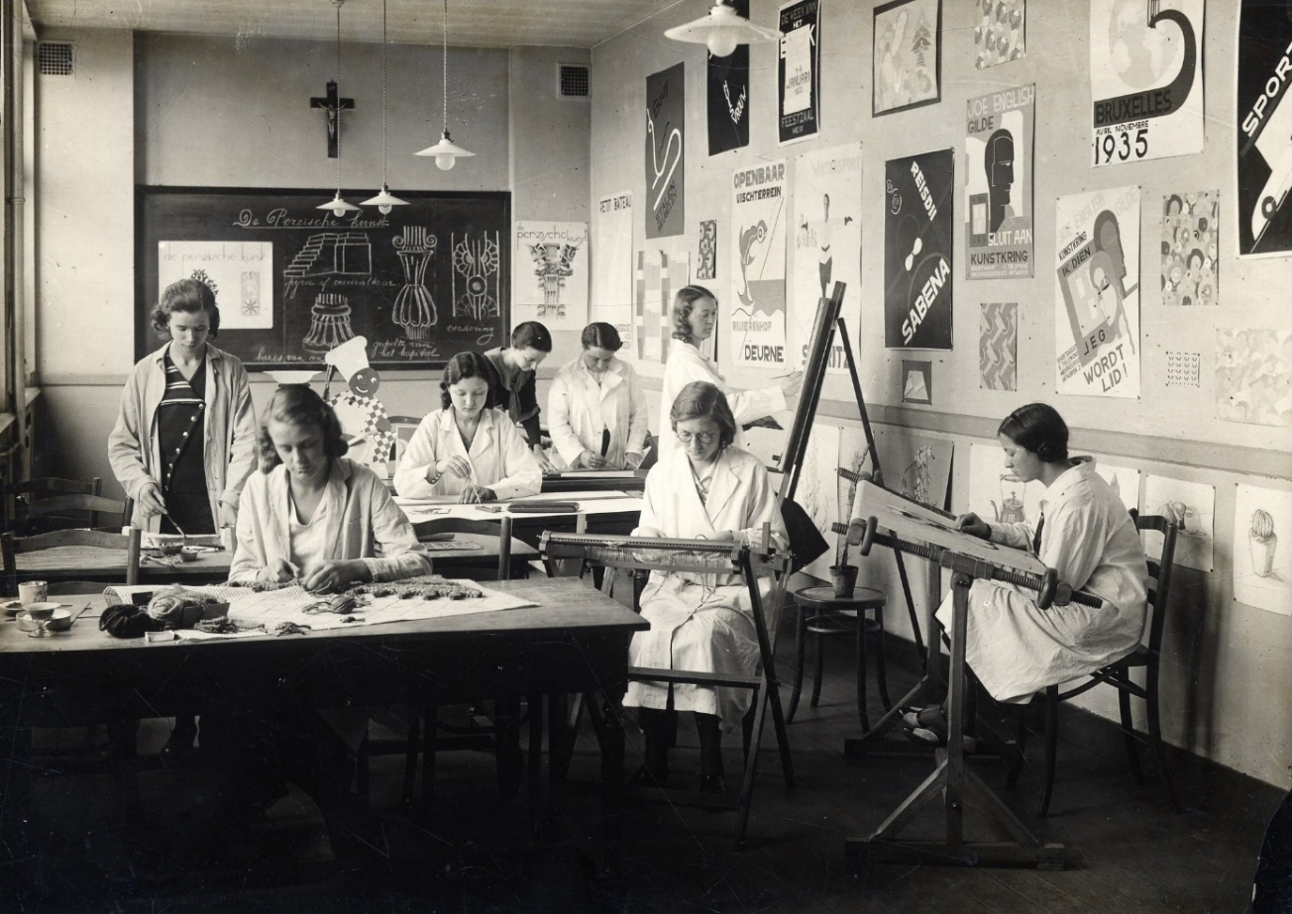
A class photograph with a.o. Martha van Coppenolle at the Technisch Instituut van Sint-Maria in Antwerp, ca. 1930. Collection City of Antwerp, Letterenhuis.

Writing sessions
Anyone who wants to contribute can participate in one of the Wikipedia writing sessions organized by the Flanders Architecture Institute in collaboration with the project partners. The writing sessions take the form of edit-a-thons, a well-known format where communities come together to write and publish on a particular topic. The aim is to train new editors and improve the quality of articles on the subject.
“Wikipedia will only contain ‘the sum of all human knowledge’ if its editors are as diverse as the population itself: you can help make that happen. And I can’t think of anything more important to do, than that.” - Sue Gardner (former director Wikimedia Foundation)
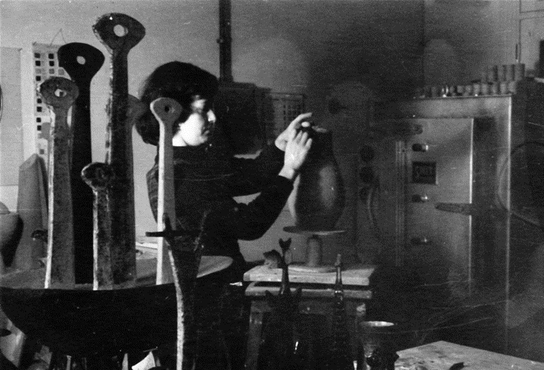 Lutgard De Meyer at work in her studio, 1955 © Paul Ausloos

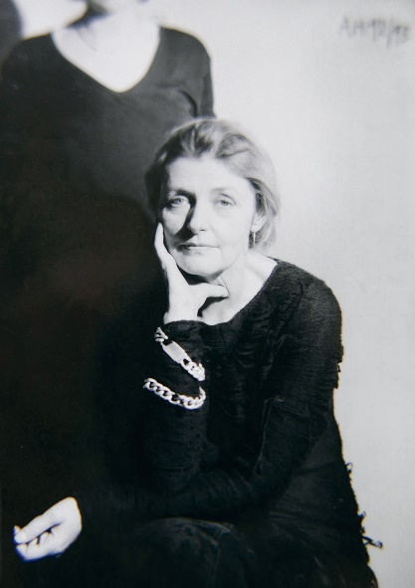
Conference
The final part of the project is an international symposium on September 23, 2021 with presentations by project participants, researchers, professionals and international experts. In addition, interested parties can participate in site visits to buildings, archives and collections that illustrate the cultural heritage of women designers and to which Wiki Women Design wants to give more visibility.

Jenny Meirens © Marina Faust

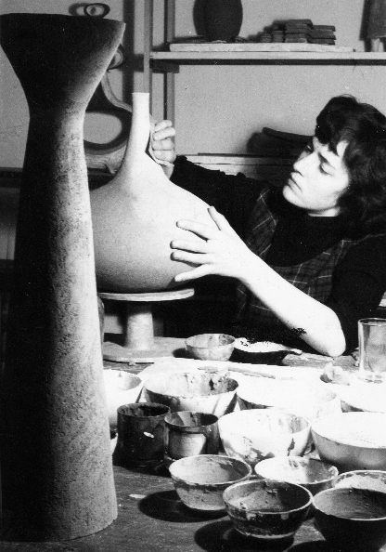
Call
Are you interested in this project or would you like to contribute as an organization, researcher or volunteer? Are you in possession of archival material about women who had an impact on the designed environment in Belgium or do you know about archival material or collections that are located in other organizations or private persons?

Let us know

Lutgart De Meyer at work in her studio in the Hoogstraat in Antwerp, 1955 © Paul Ausloos

Women in Architecture on Instagram
In collaboration with the International Center for the City, Architecture and Landscape (CIVA), the Flemish Architects Organization (NAV), the Cultural Institute of Architecture Wallonia-Brussels (ICA WB) and KRAS Architects, the Flemish Architecture Institute is launching the Women in Architecture Instagram page. Starting on International Women's Day on March 8, 2021, every week a woman active in the Belgian architectural field will give followers of the profile an insight into her activities.
Claire Bataille and Paul Ibens, ca. 1968. Archive of Claire Bataille and Paul Ibens Design, Collection Flemish Architecture Institute, Collection Flemish Community © Paul Lambert

#womeninarchitecturebelgium
@womeninarchitecturebelgium

Ambassadors
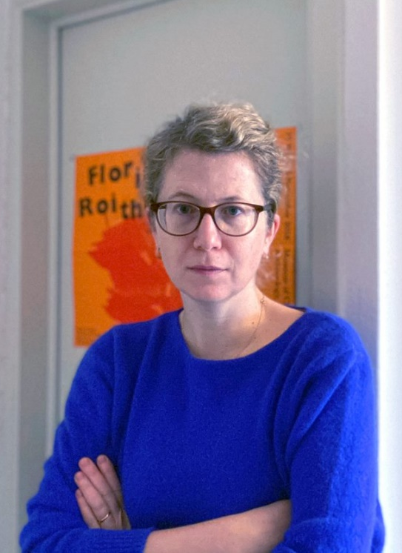
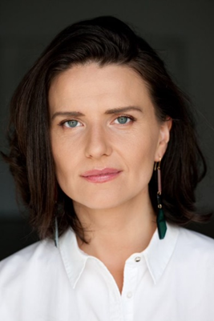
Five women who are making an impact on the contemporary design sector in Belgium recognize Wiki Women Design as an important project that they would like to contribute to. Oana Bogdan, Sara De Bondt, Stefanie Everaert, Caroline Lateur and Linde Freya Tangelder motivate why the project is important and how they think it can make a difference for a more equal gender representation in the design sector and historiography.

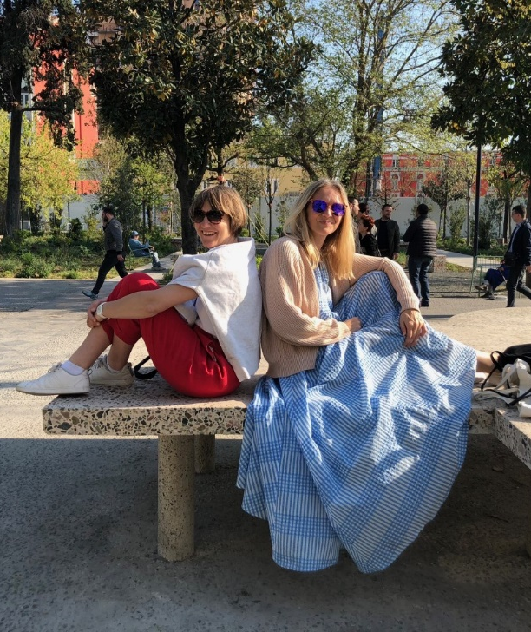
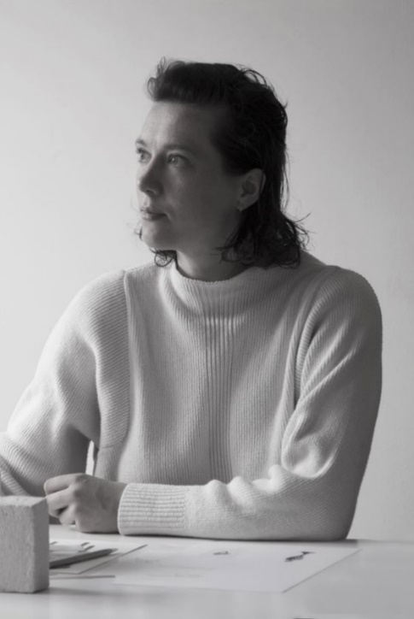
Stefanie Everaert & Caroline Lateur © Doorzon
Linde Freya Tangelder © Destroyers/Builders
Oana Bogdan © Cornel Brad
Sara De Bondt © Sara De Bondt
Oana Bogdan
Architect, founding & managing partner BOGDAN & VAN BROECK
True to her ongoing activism for a high quality Baukultur, Oana Bogdan anchors the work of BOGDAN & VAN BROECK in the ongoing public debate and questions the traditional role of the architect. Oana was a guest lecturer in Architecture and Urbanism at KU Leuven, member of the jury for the Flemish Culture Prize 2007, the Architecture and Design Evaluation Commission of the Flemish Government, Royal Commission on Monuments and Sites, Flemish Community, and the Unesco Expert Committee for the city of Bruges, State Secretary for Cultural Heritage in Romania, and co-founder of the Romanian political party PLUS (Renew Europe). She is also a member of the Board of Directors of A+ Architecture in Belgium and of the Council of the International Union of Architects (UIA), chairman of the jury for the Rotterdam Architecture Prize 2021, ambassador for Wiki Women Design and Women in Architecture in Belgium.
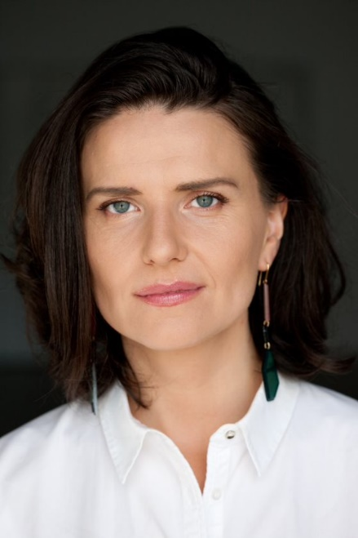
“It seems obvious to me that the role of women in architecture–now and over the years–deserves much more structural attention. The oeuvre of these female architects should, much more than is the case now, be part of our collective memory.”

Oana Bogdan © Cornel Brad

It seems obvious to me that the role of women in architecture–now and over the years–deserves much more structural attention. The oeuvre of these female architects should, much more than is the case now, be part of our collective memory.
Hilde Heynen, architect and professor at KU Leuven who has been investigating the social role of architecture in the 20th century, modernity, power and gender for more than three decades, puts it this way:
"The entanglement of the role of the architect with masculinity seems permanent and difficult to change. This mysticism is reinforced time and again in the communication of architecture to a general public, and to his own students and practitioners. It is a crucial aspect of the professional ethos that underscores the reputation and credibility of architecture as a discipline".
Catching up with female role models and an accompanying increased attention to gender balance and inclusiveness is therefore the order of the day.
Since Wikipedia is one of the most visited online encyclopedias in the world, registering and accessing information about women in architecture on Wikipedia can certainly contribute to a more realistic, inclusive view of Belgian architectural history and a more correct representation of women in the field of architecture.
As a female architect with both feet firmly on the ground, Wiki Women Design, initiated by the Flanders Architecture Institute, is a project that I very much like to support.

Sara De Bondt
Graphic designer, lecturer at KASK Gent
As a graphic designer, Sara De Bondt has acquired an important position in the cultural domain. Her clients include the V&A Museum, Barbican Centre, Tate and BOZAR. She leads a small team in her independent design studio. She has also held guest lectureships and taught at the Royal College of Art. Nowadays she is a lecturer at the KASK in Ghent. (source: Henry Van De Velde Awards, Sara De Bondt Studio)
“Wikipedia plays an important role for students and researchers. It is often a starting point for research, and for young designers looking for examples to identify with, representation can be crucial.”

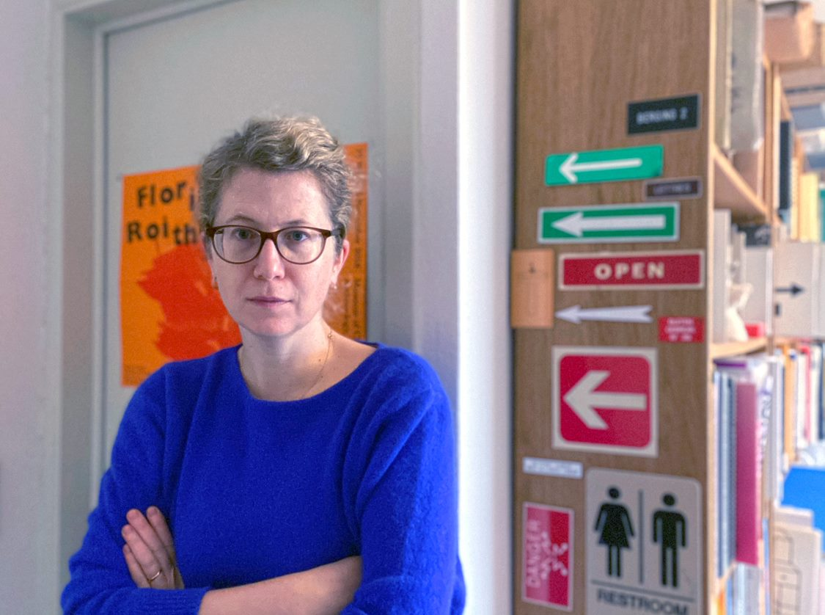
Sara De Bondt © Sara De Bondt
Although during my graphic design studies at Sint Lukas Brussels at the end of the 1990s I did not have a single female practical lecturer, as a student and starting designer I thought that gender inequality was no longer an issue. But when I was interviewed in 2010 for the book How to Be a Graphic Designer Without Losing Your Soul, half of the questions were about the fact that I am a woman instead of about my work, while the male interviewees could talk about their performance. At that point, I realized that there was a problem, and with two collaborators, I started an investigation into gender balance in graphic design. We started counting how many women and men graduated, found jobs in studios or became self-employed, and how many of them were recorded in professional organizations, publications, exhibitions, congresses, awards, juries and articles. In 2012 we presented our findings at Iaspis in Stockholm. We had converted the figures into data visualizations, which made the facts even more shocking. Although every year more girls than boys graduate in graphic design, their representation in the field is totally disproportionate. In 2019, the American professional organization AIGA had to come to a similar conclusion after its inventory of international congresses. The graphs can be consulted on the Eye on Design blog.
During the compilation of the exhibition Off the Grid last year in Design Museum Ghent, it was very important for me not to repeat this negative pattern. Martha Scotford's text, "Messy History vs. Neat History" was very inspiring, in which she argues for making history "dirty" instead of "clean". A clean history focuses on the biographies of successful, solitary designers, while a messy history is open to others: employees, office managers, interns, wives, partners, teachers, critics, historians, and other configurations. It is a way to open up the field and its history.
Wikipedia plays an important role for students and researchers. It is often a starting point for research, and for young designers looking for examples to identify with, representation can be crucial. Together with my students at KASK School of Arts, we have been writing Wikipedia articles about graphic designers in Belgium for several years now. Although there was always interest in creating articles about women, we regularly got stuck because information can be difficult to find. Thanks to the many partners in the Women Wiki Design project and the content and technical support from the Flanders Architecture Institute and Wikipedia, this year for the first time we managed to write only about female designers.

Linde Freya Tangelder
Designer, founder Destroyers/Builders and member of BRUT Collective
Linde Freya Tangelder founded the design studio Destroyers/Builders–based in Brussels and Antwerp–in 2014. The design practice carries out projects ranging from commissions to self-initiated projects, and covers the fields of both architectural furniture and interior design projects. Linde was recognized as Designer of the Year in 2019, and is one of the five designers within BRUT, a Belgian design collective. (source: Destroyers/Builders, Actief Wonen)
“By paying more attention to equal representation of male and female designers in such [architectural] projects, more women could help shape the architecture, urbanism and designed environment of the future.”

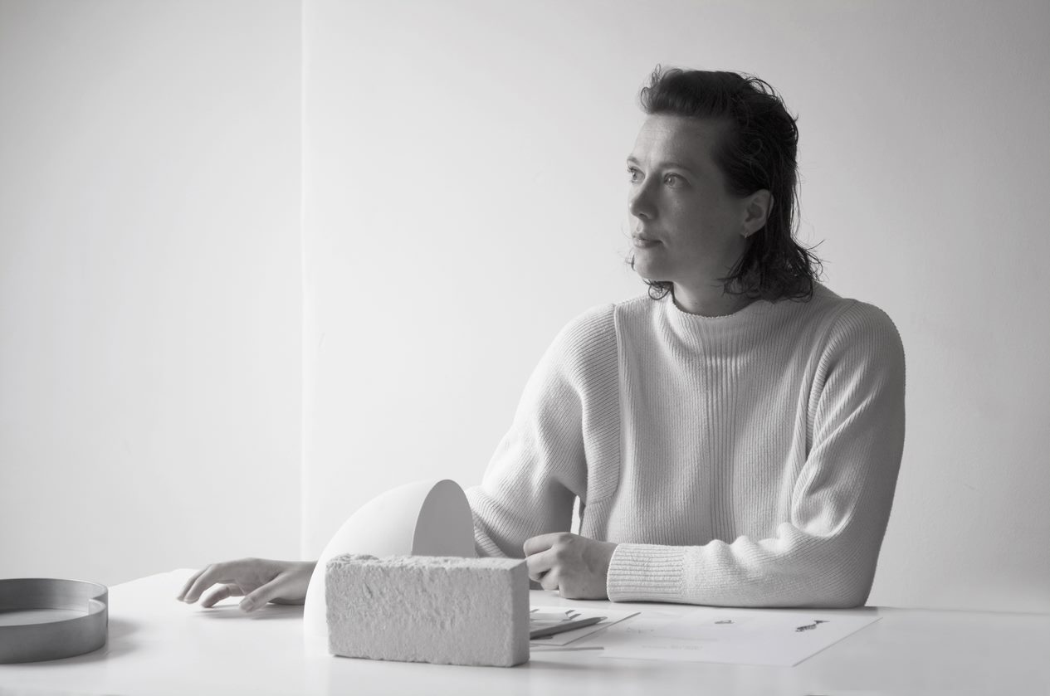
Linde Freya Tangelder © Destroyers/Builders
It is very positive that in recent years the attention for women in the design sector has increased. There is a great opportunity to achieve a more equal representation of women in the field, step by step. It is important to carry on with this and maintain this interest in women in the creative sectors from now on.
Wiki Women Design contributes to this process with a great approach. The project documents women in the design sector in Belgium and discloses this knowledge on Wikipedia, a hugely popular encyclopedia that is freely available to everyone. This knowledge can continue to grow thanks to contributions from volunteers and researchers, gradually creating a more inclusive and truthful design history.
This way, the project offers role models to the young generation of designers. It is important to see that women can also be (interior) architects, designers, graphic designers and product developers. By the way, role models remain important throughout the entire career. I myself regularly fall back on inspiration I draw from architects and artists, which gives me the strength to face difficulties and complete projects. Role models offer the courage to dare to become a designer, as well as the confidence and motivation to persevere.
Furthermore, Wiki Women Design can have a positive influence on existing gender relations in the sector. I notice that certain architectural projects are still very ambitious aspirations for women, such as public procurements. For these public commissions, established designers with strong networks are often selected, which leaves little room for diversity in gender and age. By paying more attention to equal representation of male and female designers in such projects, more women could help shape the architecture, urbanism and designed environment of the future.

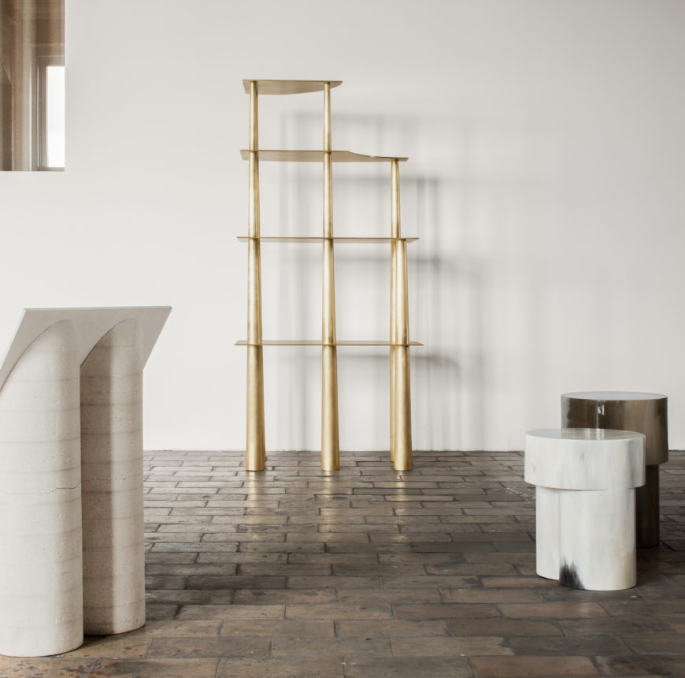
High Section illustrates the inspiration that Linde Freya Tangelder draws from architecture.
High Section, 2019, brass, 156 × 75 × 45cm, edition: 12 (+ 2 AP) © Destroyers/Builders, Jeroen Verrecht

Stefanie Everaert & Caroline Lateur
Interior designers and designers, founders Doorzon interior architects
In 2005, Stefanie Everaert and Caroline Lateur founded Doorzon interior designers. Their projects were initially in the private sector, ranging from new buildings and renovations to smaller interventions such as specific made-to-measure furniture. Over the past 15 years, however, their field of work has expanded to include public and international projects, numerous prestigious competition designs, scenographies and exhibitions. In 2013, a first monograph dedicated to their work was published in an edition of Vlees en Beton. In 2016, Doorzon interior architects was selected for the 15th Venice Architecture Biennale, together with architects devylder vinck taillieu and Filip Dujardin. Everaert and Lateur also both work as lecturers at the KU Leuven. (source: Doorzon)
“ During our studies we hardly had any female role models apart from Charlotte Perriand, Marie-José Van Hee and Claire Bataille. If a simple search on Google can reveal more female names, that's a very important step forward.”

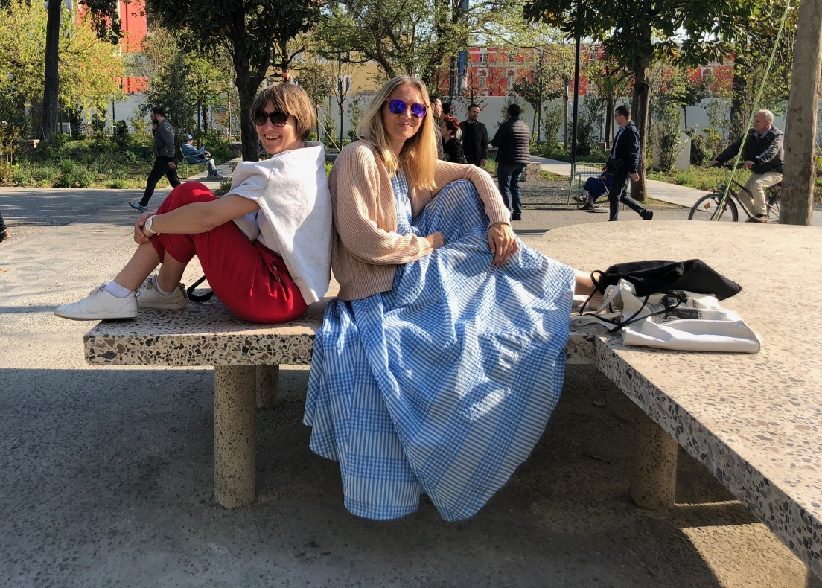
Stefanie Everaert and Caroline Lateur with a conference table they designed for the Center for Openness and Dialogue in Tirana, reproduced on the Skanderberg Square © Doorzon

Wiki Women Design makes an important contribution to a broader cultural shift in the field of (interior) architecture, where sexism is deeply rooted in working culture and education. The world of architecture is still a man's world. In our 15-year career as interior architects, we have very often asked ourselves the question: is it really up to us or are we really some of the few women who actively come out with our work in Flanders? When we take part in architectural competitions for public projects, we find that we are the only female interior architects who play at that level. Usually we are also the only women in the teams for these assignments. That is confronting.

An eye-opener for us was Hilde Heynen's research that showed that although more women than men graduate as architects, fewer women are active in the field. Moreover, the women who are active as architects are much less visible: only 21% of the published projects in the Architecture Book of Flanders and only 8% of the selected designs in the magazine A+ are designed by women. Thus, this issue is truly rooted in the policy. The bottom line is that as a woman you have fewer chances to be published, to make exhibitions or to be honored. Moreover, there is still a big taboo around this subject.
Spreading more knowledge about female (interior) architects who have an impact on the design world is a small step that can have a big impact in the long run. During our studies we hardly had any female role models apart from Charlotte Perriand, Marie-José Van Hee and Claire Bataille. If a simple search on Google can reveal more female names, that's a very important step forward. That is another reason why we want to support this project: to make it easier for future generations and to contribute to a positive future of our discipline.

Quotes
The following statements by architects and designers, teachers and researchers, and members of the Wikipedia community illustrate the issues that inspired Wiki Women Design. The statements of these women form a clear framework for the project and its objectives.
“[…] Although women have had a great influence on the design practice of the twentieth century, mainstream history had failed to recognize their contributions.” - Pinar Kaygan (professor Industrial Design, Middle East Technical University, Ankara, Turkey)
“[…] a gender-neutral industry—indeed, a gender-neutral built environment—if desired, cannot be simply willed into existence. It must be fought for. Invisibility is a sign that there is still much more work to do.” - Jane Hall (architect, author of Breaking Ground. Architecture by Women (2019)) and Audrey Thomas-Hayes (designer), members of the Assemble design collective
“Desiring no difference between the sexes . . . runs the risk of recognizing the professional title of architect as male, rather than acknowledging that it could mean something—anything—else.” - Jane Hall
“Faced by this multitude of renowned female graphic designers, one is compelled to question the practices of remembrance that cause them to disappear - and the paucity of institutions that can determine historical memory. (…) And once again, it demonstrates the great need for a revision of the traditional stories told by design history.” - Gerda Breuer (art and design historian, professor emeritus Bergische Universität Wuppertal) and Julia Meer (designer and design historian)
“Contributing to Wikipedia and other online databases represents a real opportunity to provide students and younger readers, and the larger public, with a more accurate perception of women’s participation in architecture.” - Despina Stratigakos (architectural historian, professor University at Buffalo, New York)
“(…) while histories of women are now increasingly available, they have yet to become readily visible.” – Despina Stratigakos

"Patriarchal expectations and masculinist values are very deeply ingrained in this [architectural] culture, although few of its practitioners are aware of this strong but implicit bias. It will therefore require a conscious and shared effort of all those involved to change all this and to leave sexism behind." - Hilde Heynen (architecture theorist and historian, professor KU Leuven)
“Women have always been there, but we have overlooked their contributions.” - Alexandra Lange (architecture and design critic)
“Gender is global… You cannot do [feminist work] globally, from the top. It is a collectivity we must produce, not through interpreters.” - Gayatri Chakravorty Spivak (literary theorist and feminist critic, professor Columbia University, New York)
“[…] feminist architecture history—like feminism in general—has nearly disappeared.” - Mary McLeod (architecture historian and theorist, professor Columbia University, New York)
“Wikipedia will only contain ‘the sum of all human knowledge’ if its editors are as diverse as the population itself: you can help make that happen. And I can’t think of anything more important to do, than that.” – Sue Gardner (journalist, former director Wikimedia Foundation)

Bibliography of the quotes
Breuer, Gerda and Julia Meer. Women in Graphic Design: 1890 - 2012. Berlin: Jovis, 2012.
Hall, Jane. Breaking Ground. Architecture by Women. London and New York: Phaidon, 2019.
Heynen, Hilde. "Wo Sind All'die Frauen Hin? Zur Sichtbarkeit Von Frauen in Der Architekturszene Flanderns." Pepchinski, Mary, Budde, Christina, Voigt, Wolfgang, and Peter Cachola Schmal. Frau Architekt. Seit Mehr Als 100 Jahren: Frauen Im Architekturberuf. Tübingen: Wasmuth, 2017. 259-65.
Kaygan, Pinar. "Gender, Technology, and the Designer's Work: A Feminist Review." Design and Culture 8.2 (2016): 235-52.
Lange, Alexandra. “The Hidden Women of Architecture and Design”. The New Yorker (June 4, 2018). Consulted on December 22, 2020. https://www.newyorker.com/culture/cultural-comment/the-hidden-women-of-architecture-and-design.
McLeod, Mary. “Perriand: Reflections on Feminism and Modern Architecture.” Harvard Design Magazine 20 (2004). Consulted on December 22, 2020. http://www.harvarddesignmagazine.org/issues/20/perriand-reflections-on-feminism-and-modern-architecture.
Spivak, Gayatri Chakravorty. “Can There Be a Feminist World?” Public Books (May 15, 2015). Consulted on December 22, 2020. https://www.publicbooks.org/can-there-be-a-feminist-world.
Stratigakos, Despina. “Unforgetting Women Architects: From the Pritzker to Wikipedia.” Places Journal (April 2016). Consulted on December 22, 2020. https://doi.org/10.22269/130603.

Press images
The images below can serve as images for the press. They are accompanied by a short, explanatory introduction and the correct caption.

Download the press images in HD

May Néama

May Néama (Vienna, 1917 - Antwerp, 2007) was a painter, illustrator, sculptor and graphic artist from Antwerp, she also designed theater scenery and theater costumes. (Source: Wikipedia)

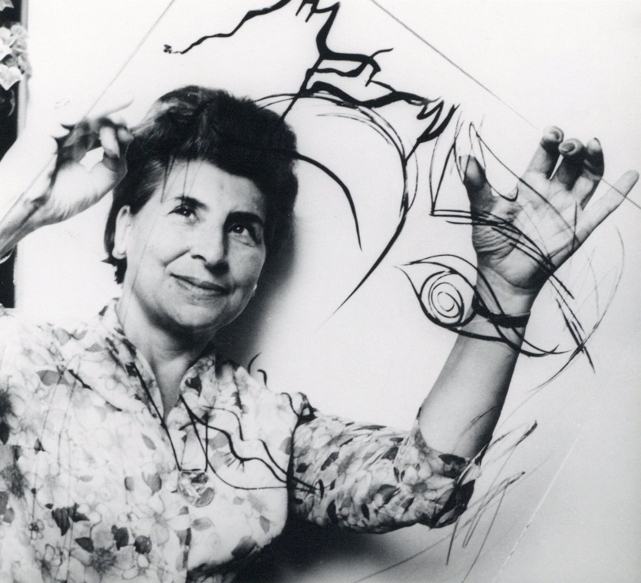
May Néama with her work for the provincial prize for graphic arts, 1965. Collection City of Antwerp, Letterenhuis

Martha Van Coppenolle

Martha Van Coppenolle (Merksem, April 13, 1912 - Antwerp, September 22, 2004) was a Flemish-Belgian graphic designer, illustrator and visual artist. She is known as one of the most influential Flemish illustrators of the twentieth century. (Source: Wikipedia)

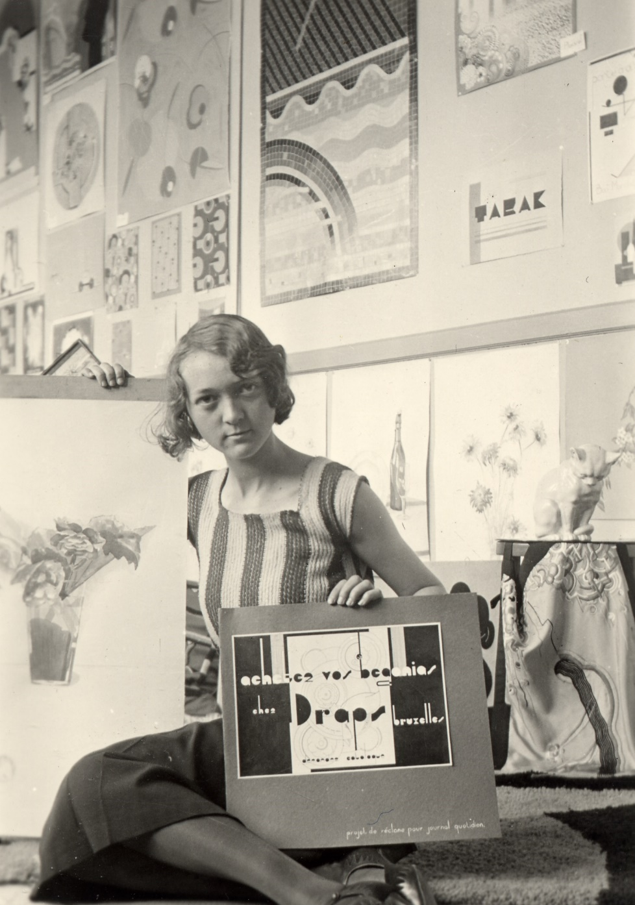
Martha van Coppenolle in her atelier at the end of her studies, ca. 1930. Collection City of Antwerp, Letterenhuis

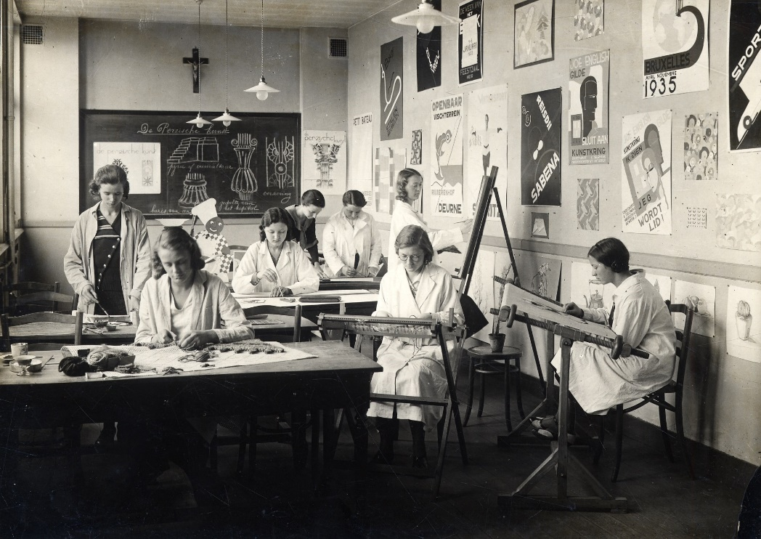
A class photograph with a.o. Martha van Coppenolle at the Technisch Instituut van Sint-Maria in Antwerp, ca. 1930. Collection City of Antwerp, Letterenhuis

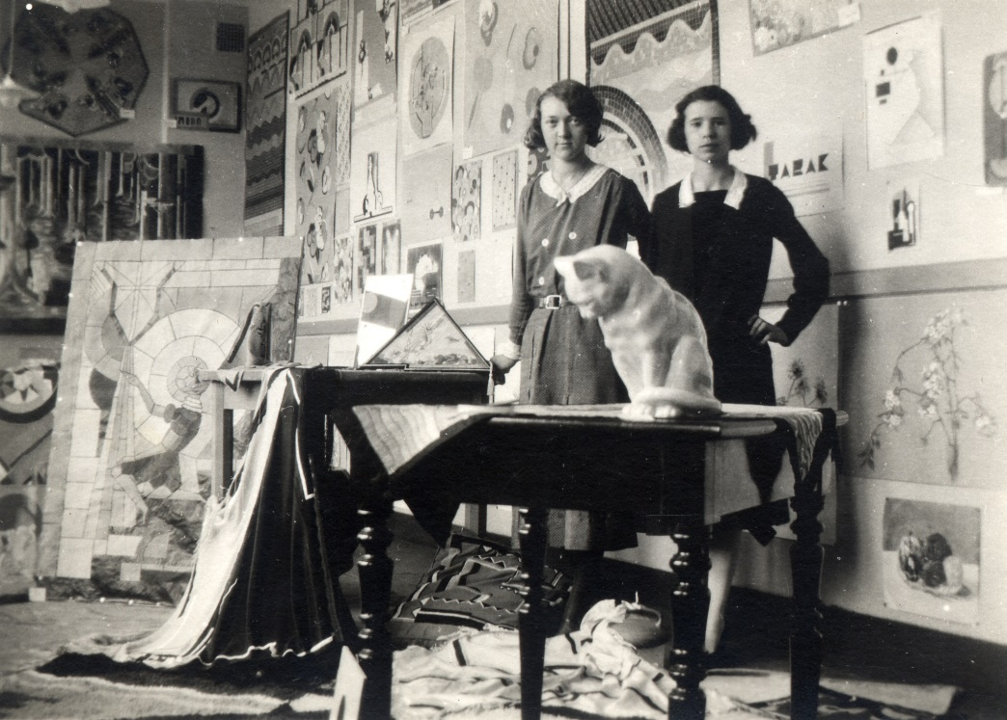
Martha Van Coppenolle in an atelier with a friend, 1931. Collection City of Antwerp, Letterenhuis
Claire Bataille
Claire Bataille (Antwerp, 10 April 1940) is a Belgian contemporary interior architect. Claire Bataille and Paul Ibens studied interior architecture at the Antwerp academy where they were taught by Jules De Roover. In 1968 they jointly started the office Bataille-Ibens Design in Antwerp. (Source: Wikipedia)

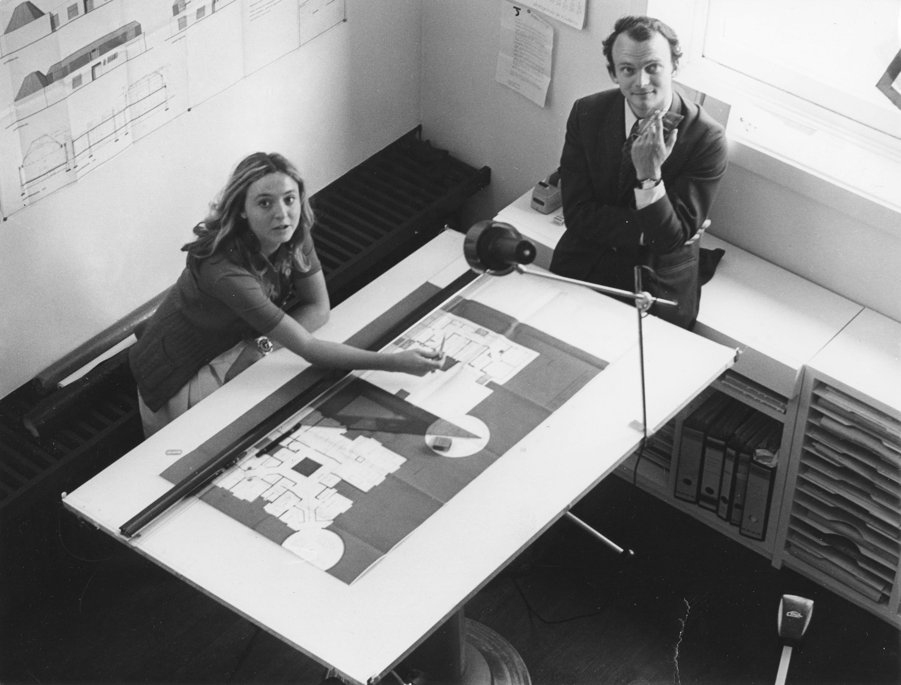
Claire Bataille and Paul Ibens, ca. 1968. Archive of Claire Bataille and Paul Ibens Design, Collection Flemish Architecture Institute, Collection Flemish Community © Paul Lambert
Jenny Meirens
Jenny Meirens was co-founder of the legendary Belgian fashion house Maison Martin Margiela and right hand of the designer. (Source: De Standaard)

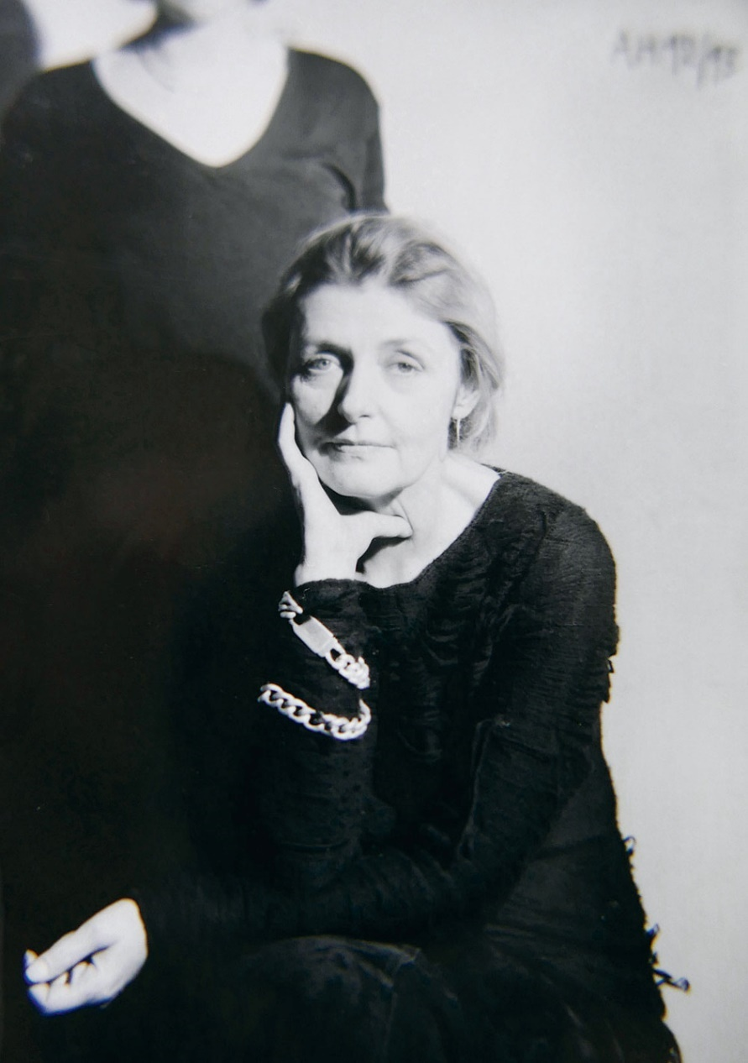
Jenny Meirens © Marina Faust
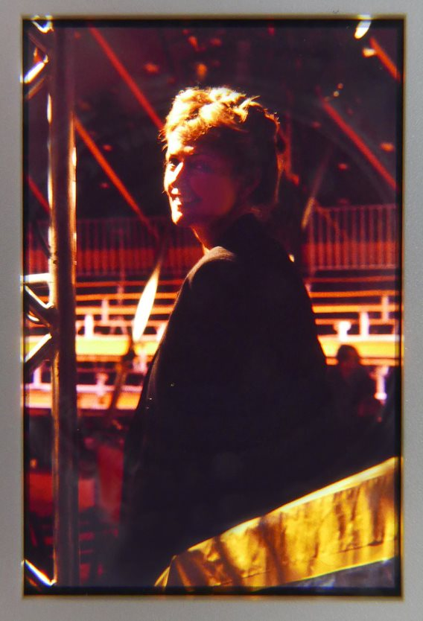
Jenny Meirens © Marina Faust
The copyrights of all included images remain with the individual copyright holder. Reproduction, printing and downloading of any content is prohibited by copyright laws and international conventions without the express written permission of the copyright holder. All rights reserved. The images are all © Marina Faust

Lutgart De Meyer
Lutgart De Meyer (Geel, 1924) is a Belgian ceramist. (Source: Antwerpen)

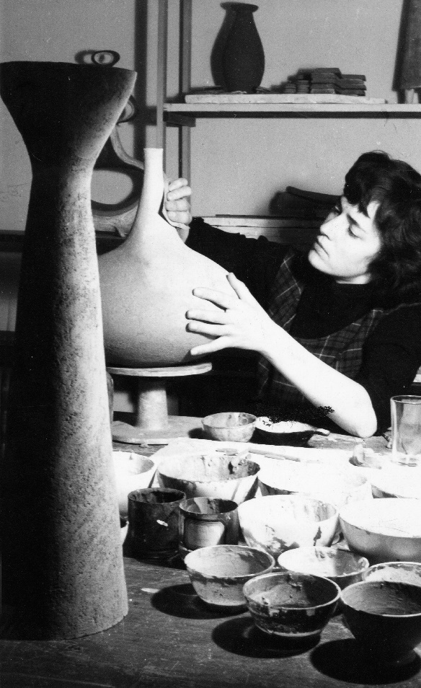
Lutgart De Meyer at work in her studio in the Hoogstraat in Antwerp, 1955 © Paul Ausloos
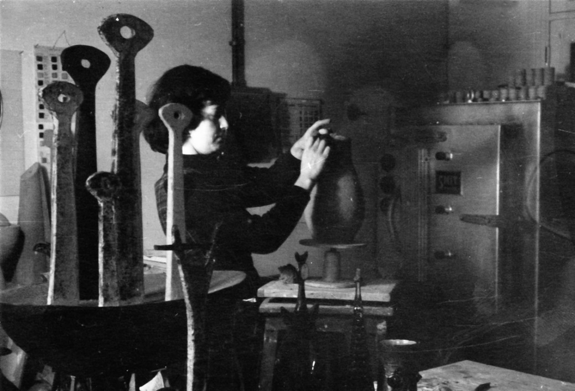
Lutgart De Meyer at work in her studio, 1955 © Paul Ausloos
France Andrevie
France Andrevie was a futuristic Belgian fashion designer working in Paris. This Belgian designer is known for her designs from the disco era that range from avant-garde to subtle, masculine-inspired costumes. (Source: Morphew)

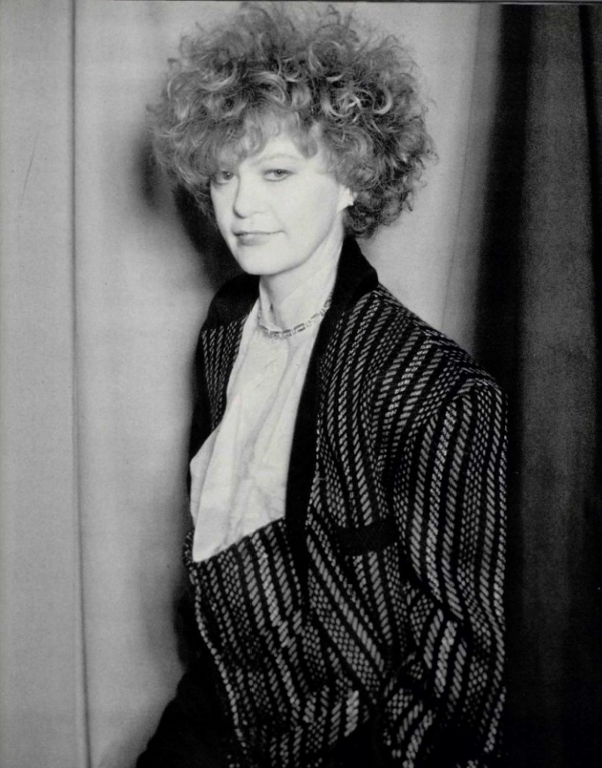
France Andrevie, ca. 1980 © Antonio Guccione

Elisabeth De Saedeleer
Elisabeth De Saedeleer (1902, Sint-Martens-Latem - 1972, Brussels) was a Belgian painter and textile artist. (Source: rkd)

Elisabeth De Saedeleer and two sisters, 1923 © Archives of Contemporary Art, Royal Museums of Fine Arts of Belgium, Businarias
Nicole Van Goethem
Nicole Van Goethem (Antwerp, May 31, 1941 - March 3, 2000) was a Belgian illustrator, cartoonist and animator. Her film A Greek tragedy won an Oscar for best short animation film in 1986. (Source: Wikipedia)

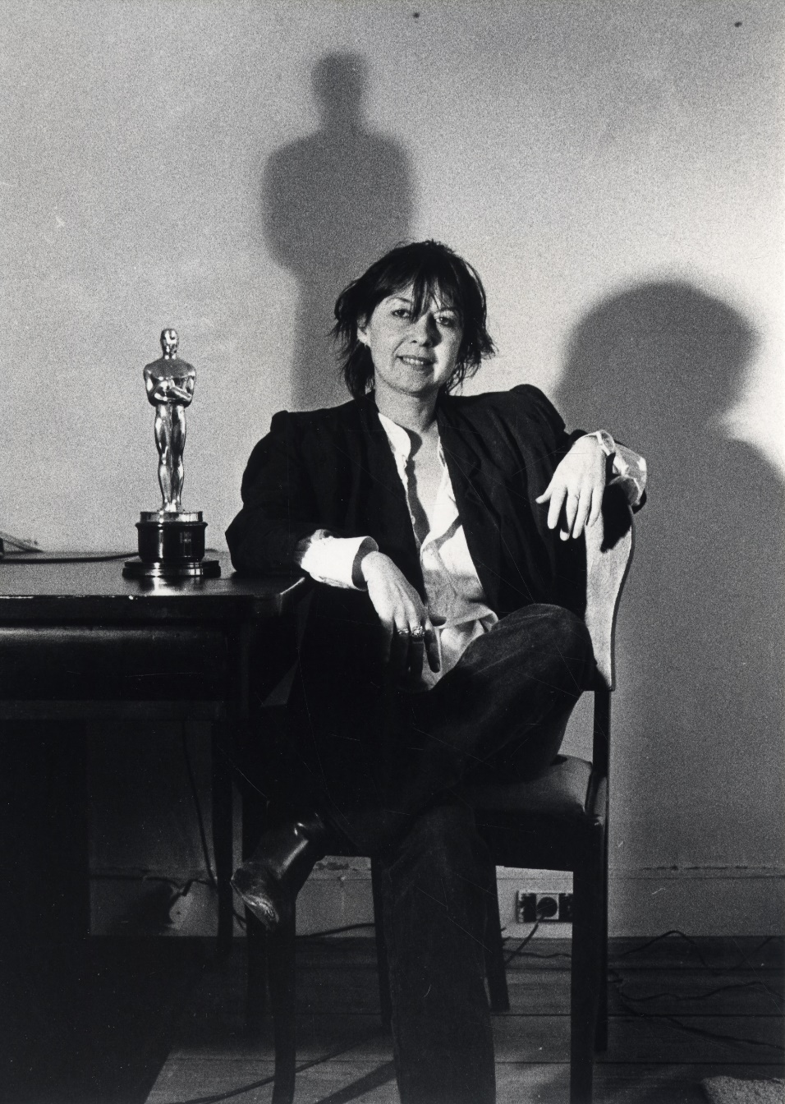
Nicole Van Goethem, Collection City of Antwerp, Letterenhuis © Marek Stawski

Students at La Cambre
The École nationale supérieure des arts visuels (ENSAV) is a high school of the French Community in Belgium, located in the Abbey of the Campsite near Brussels. In art circles it is known as "Ter Kameren" or "La Cambre". (Source: Wikipedia)

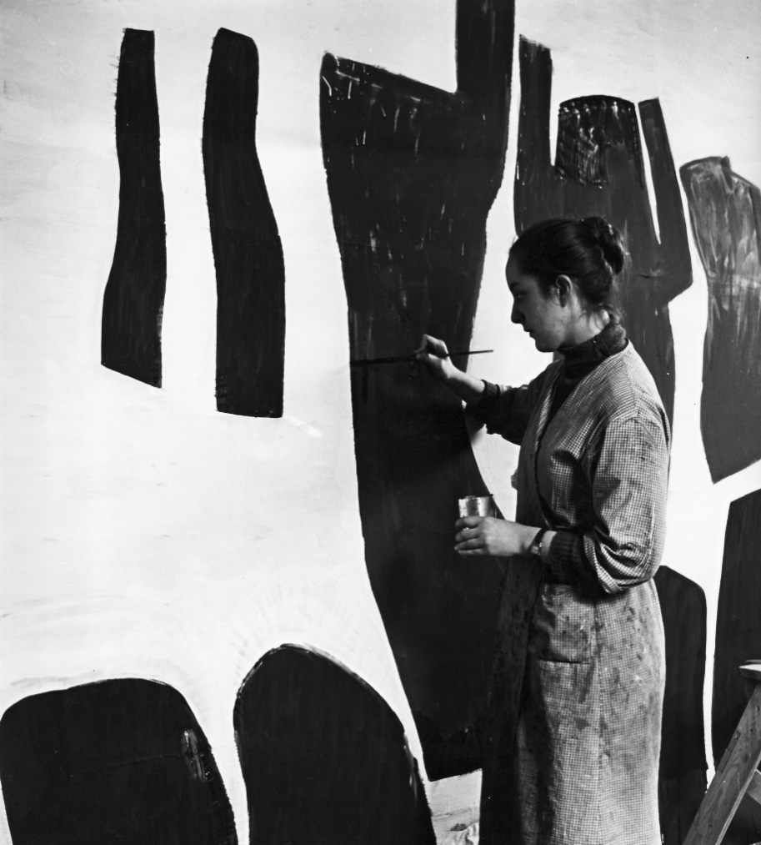
Painting student, class of Paul Delvaux at La Cambre, ca. 1960. École nationale supérieure des arts visuels - La Cambre, Brussels.
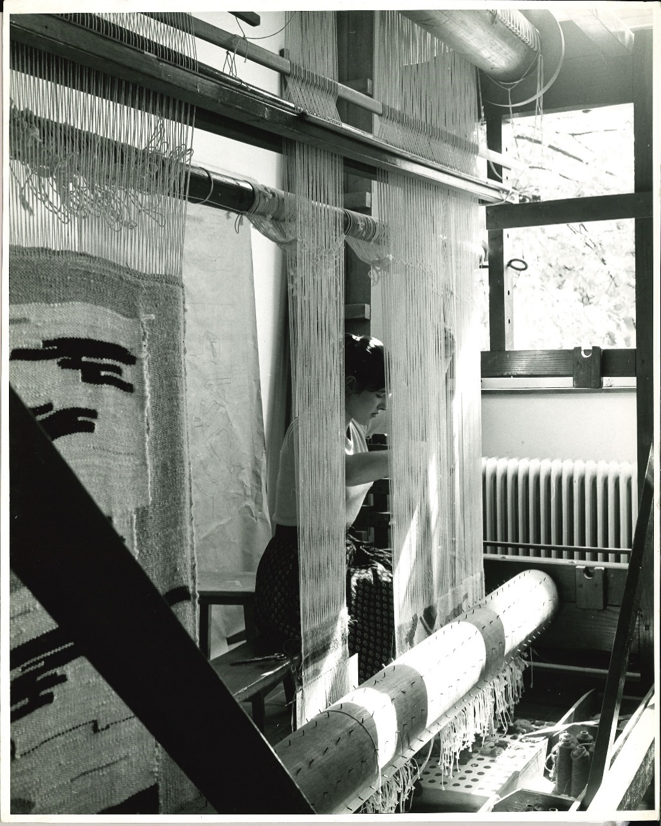
Weaving student, class of Marie-Louise Overloop-Zimmer at La Cambre, ca. 1960. École nationale supérieure des arts visuels - La Cambre, Brussels.

Simone Guillissen-Hoa
Simone Guillissen-Hoa (March 7, 1916, Beijing - May 30, 1996, Brussels) is a Belgian architect, one of the first women to practice architecture in Belgium and the first to build a house there. After World War II, she participated in the renovation of residential complexes, designing many modernist houses that fit harmoniously into the local style, using similar materials. (source: Wikipedia)

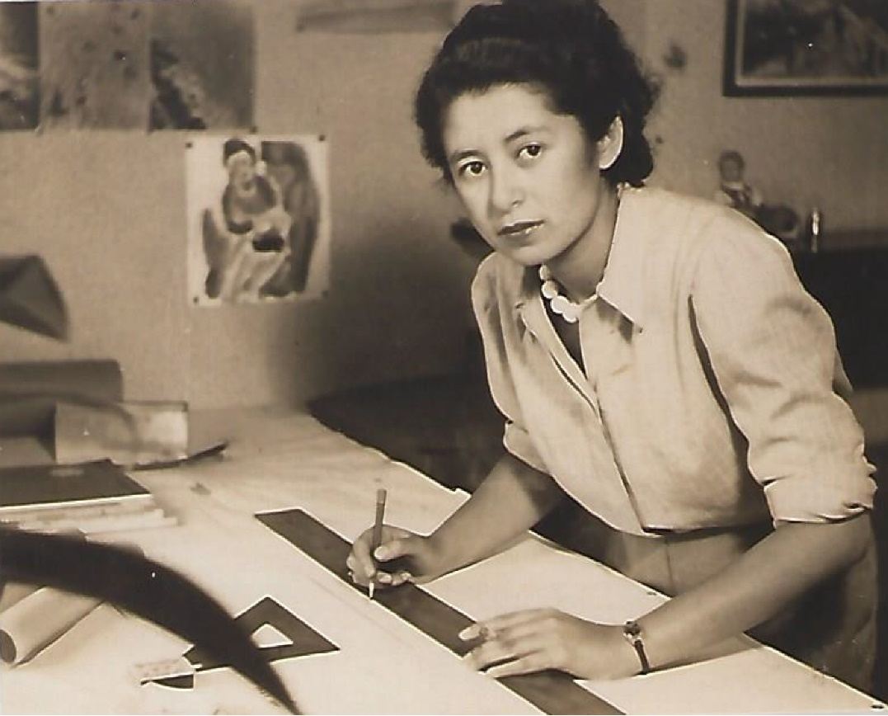
Simone Guillissen Hoa, ca. 1942, Fonds Simone Guillissen-Hoa, Archives J.P. Hoa

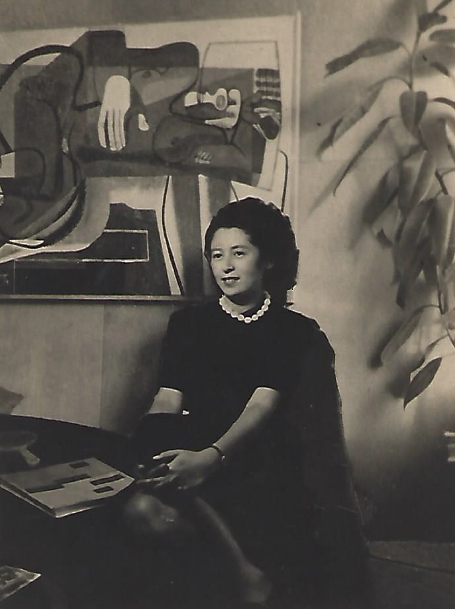
Simone Guillissen-Hoa, 1941-1942, Fonds Simone Guillissen-Hoa, Archives J.P. Hoa

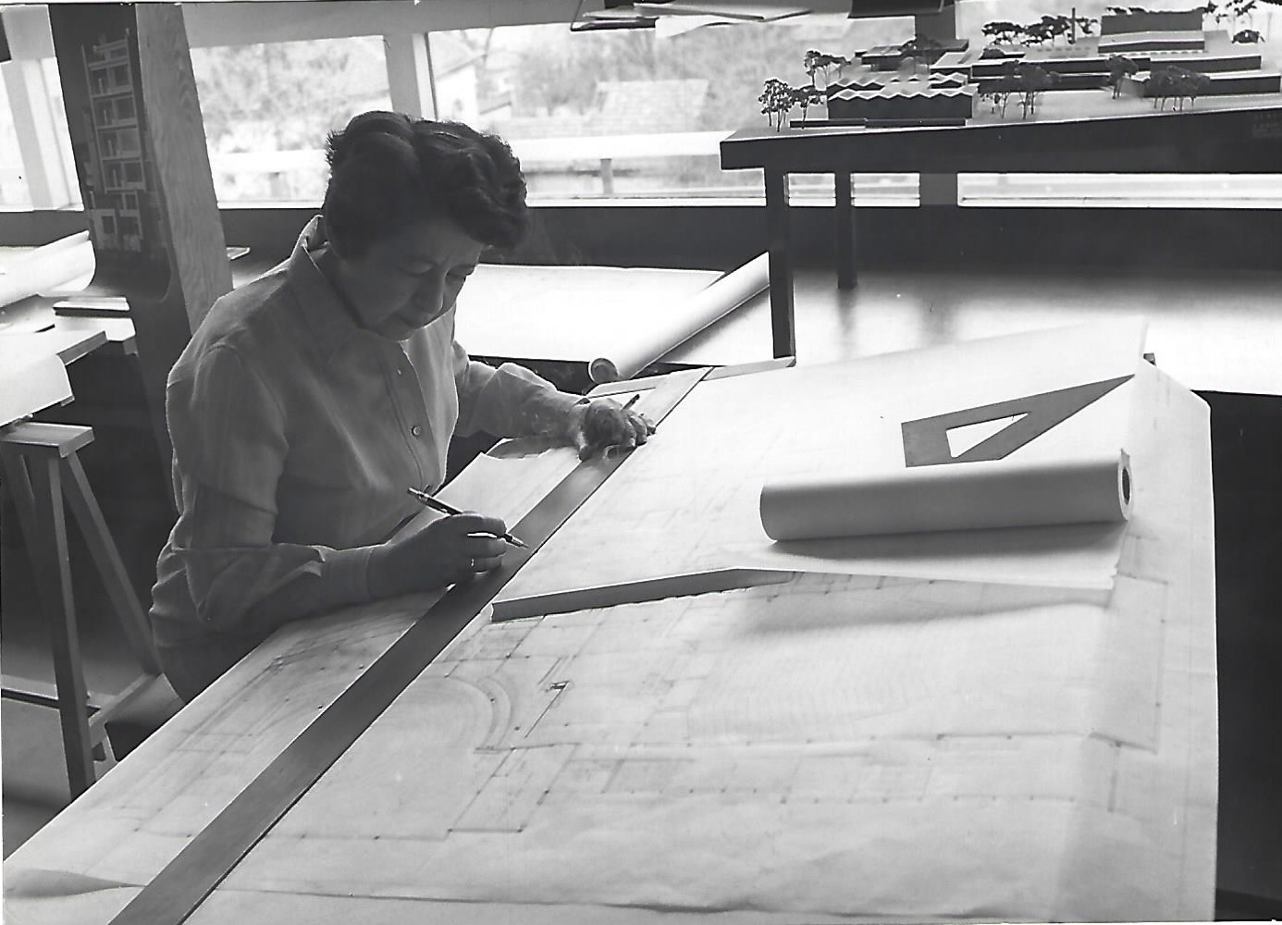
Simone Guillissen-Hoa in her office, Rue Langeveld, Uccle, Brussels, 1970 © Roularta Media Group NV/SA – Femmes d'Aujourd'hui – photographer Roland d'Ursel, Fonds Simone Guillissen-Hoa, Archives J.P. Hoa

Simone Guillissen-Hoa is working on the project for the Maison de la Culture in Tournai, a model of which can be seen in the background as well as a photo of the building she designed on Avenue Legrand.
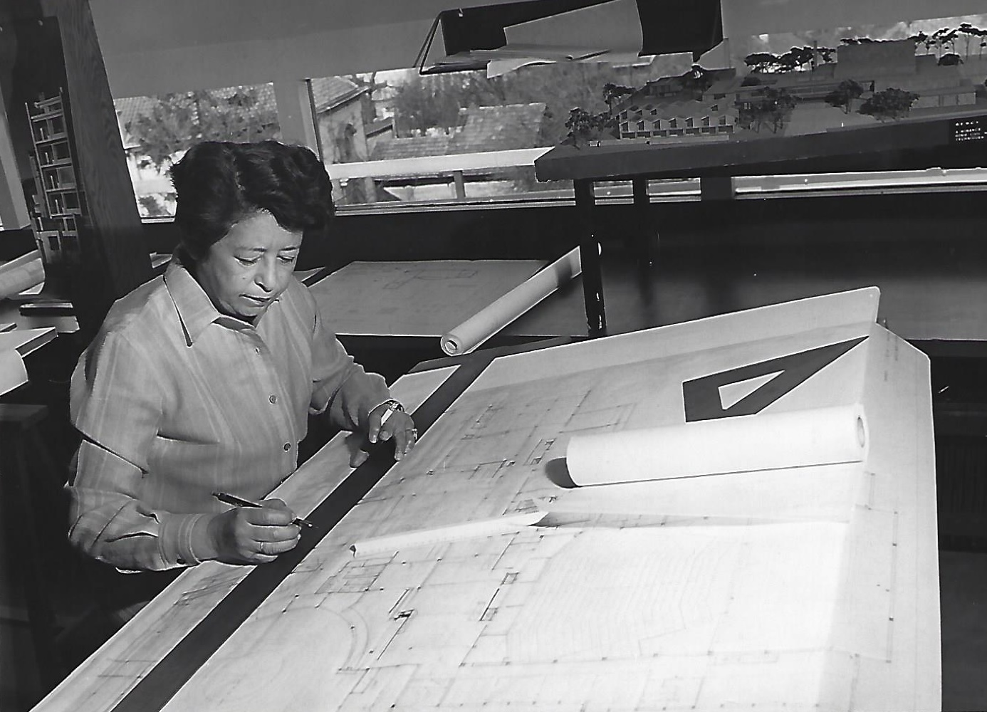
Simone Guillissen-Hoa in her office, Rue Langeveld, Uccle, Brussels, 1970 © Roularta Media Group NV/SA – Femmes d'Aujourd'hui – photographer Roland d'Ursel, Fonds Simone Guillissen-Hoa, Archives J.P. Hoa

Simone Guillissen-Hoa is working on the project for the Maison de la Culture in Tournai, a model of which can be seen in the background as well as a photo of the building she designed on Avenue Legrand.
Yvette Lauwaert
Fashion designer
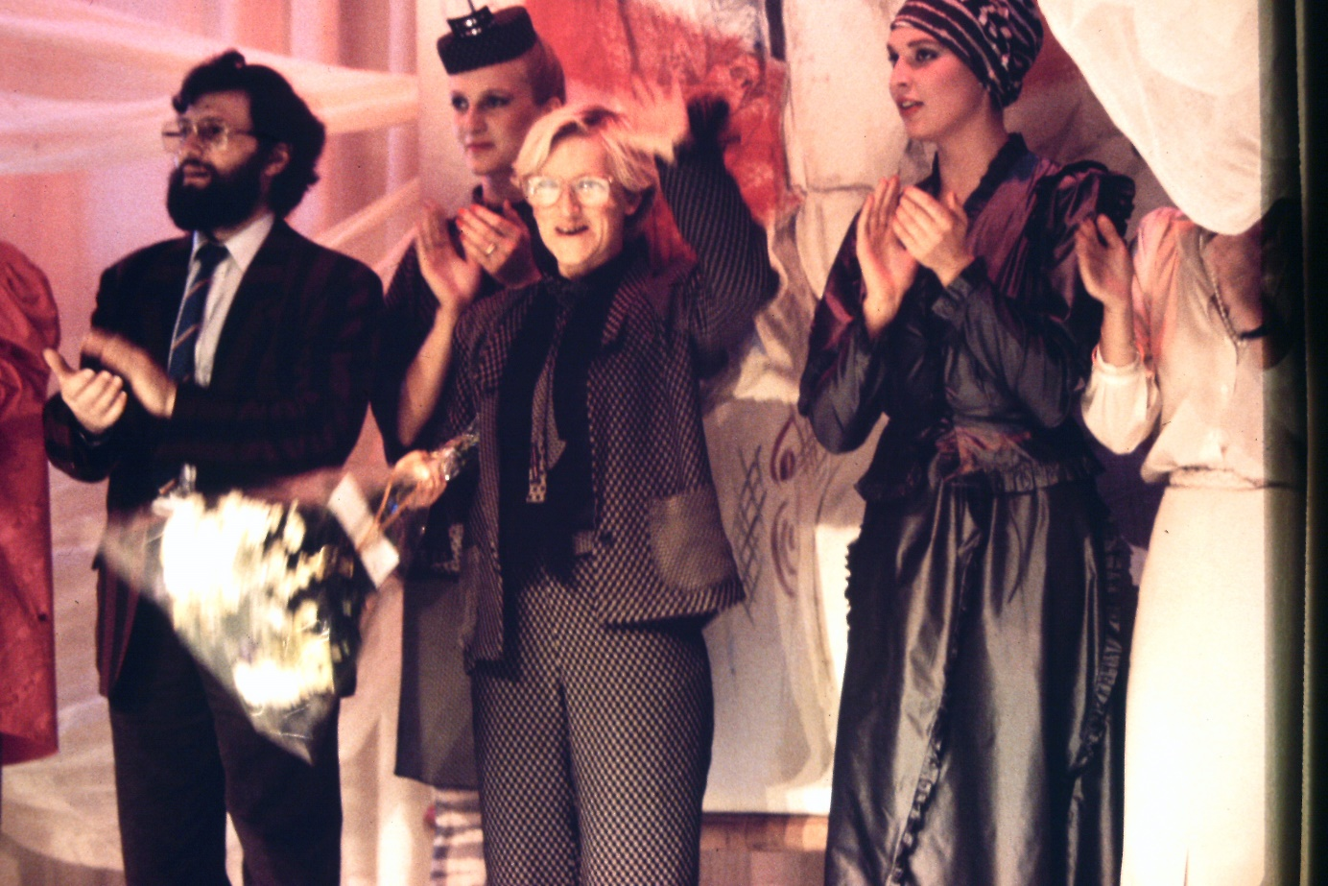
© Yvette Lauwaert

Writing sessions
Anyone who wants to contribute can participate in one of the Wikipedia writing sessions organized by the Flemish Architecture Institute in collaboration with the project partners. Some partners have already set the dates for their writing session, while others will be communicated later in the spring. Below is a preliminary overview of the Wiki Women Design edit-a-thons.
Docomomo x ULB, Faculté d'Architecture La Cambre Horta
March 29 - April 2, 2021
Location: Library ULB, Faculté d'Architecture La Cambre Horta ( Place Flageyplein 19, 1050 Brussels)
Focus: Women at architecture schools; writing session takes place within the framework of the Semaine d'innovation pedagogique
Design Museum Gent
April 21, 2021
Location: Design Museum Gent (Jan Breydelstraat 5, 9000 Ghent)
Focus: Female designers in the National Documentation Centre for the Arts and Crafts (NDK)
Art & History Museum
May 15, 2021
Location: Art & History Museum (Jubelpark 10 Parc du Cinquantenaire, 1000 Brussels)
Focus: Women in the collection of the Art & History Museum, in the decorative arts and in lacework
Flanders Architecture Institute
May 20, 2021
Location: Music studio, deSingel (Desguinlei 25, 2018 Antwerpen)
Focus: Women who have left their mark on Belgian design heritage
UHasselt x PXL-MAD x Z33 x Modemuseum Hasselt
May 21, 2021
Location to be confirmed
Focus: Women in various design disciplines, focused on the Limburg region
AR-TUR x Berg en Nete x Erfgoed Noorderkempen x Erfgoedcel k.Erf x Kempens Karakter
May 27, 2021
Location: De Warande (Warandestraat 42, 2300 Turnhout)
Focus: Designers, but also women who through organizations have had an impact on the designed environment in the Kempen
Design Museum Gent x Flanders DC
June 16, 2021
Location: Design Museum Gent (Jan Breydelstraat 5, 9000 Ghent)
Focus: Contemporary Belgian designers
Design Museum Brussels
June 19, 2021
Location: Design Museum Brussels (Belgiëplein 1 Place de Belgique – 1020 Brussels)
Focus: Women in the collection of the Design Museum Brussels, in sight of the exhibition season 2021-2022

Modemuseum Hasselt x MoMu Antwerpen x Eperon d'Or Izegem
June 28, 2021
Location: Modemuseum Hasselt (Gasthuisstraat 11, 3500 Hasselt)
Focus: Women who have left their mark on Belgian fashion
Matrimony Days
September 24, 2021
Location: Library ULB, Faculté d'Architecture La Cambre Horta (Place Flageyplein 19, 1050 Brussel)
Focus: Women who've contributed to the designed heritage in Belgium

Practical information
Project team
Annelies Nevejans (Project Officer)
Nina Serulus (Consultant Design)
Tine Poot (Consultant Design)
Michel D'hoe (Project Officer)
Wim Lowet (Consultant Digital Archive)
Egon Verleye (Communication & PR)

Project partners

AR-TUR, Art & History Museum, AVG-Carhif, Berg en Nete, Design Museum Brussels, Design Museum Gent, Docomomo, Eperon d'Or, Erfgoed Noorderkempen, Erfgoedcel k.Erf, Flanders DC, Ghent University, Hasselt University, KASK, Kempens Karakter, KU Leuven, Matrimony Days, meemoo, Modemuseum Hasselt, MoMu Antwerpen, Open Knowledge Belgium, PXL-MAD, Regionaal Landschap Kleine en Grote Nete, RoSa vzw, ULB, Faculté d'Architecture La Cambre Horta, University of Antwerp, Wikimedia Belgium, Z33

The project was made possible thanks to the support of the Flemish Community.

Web addresses

Wiki Women Design website
Wiki Women Design (2020-2021) project page on Wikipedia
Instagram: @vlaams_architectuurinstituut
Facebook: Vlaams Architectuurinstituut
#wikiwomendesign

Press contact

Michel D’hoe

michel.dhoe@vai.be
+32 (0) 471/ 23 35 48
www.vai.be

Download the press images

